1/ **VL With Quadratic: length, e1, e2, k, alpha, anomalies, time**

(0-21599), 3, 0.3, 1, 3, (10870 - 10951), 00:01:24

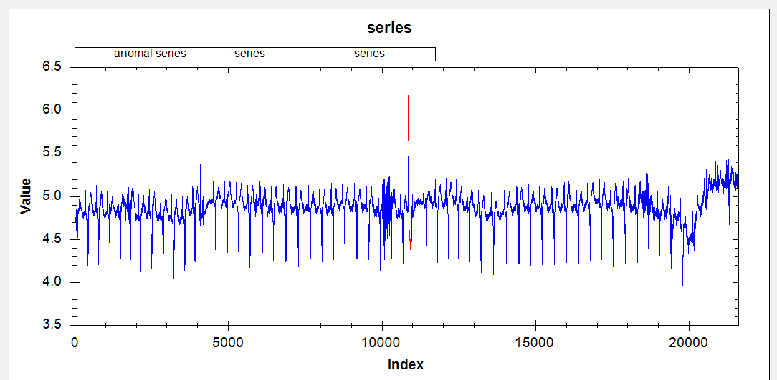

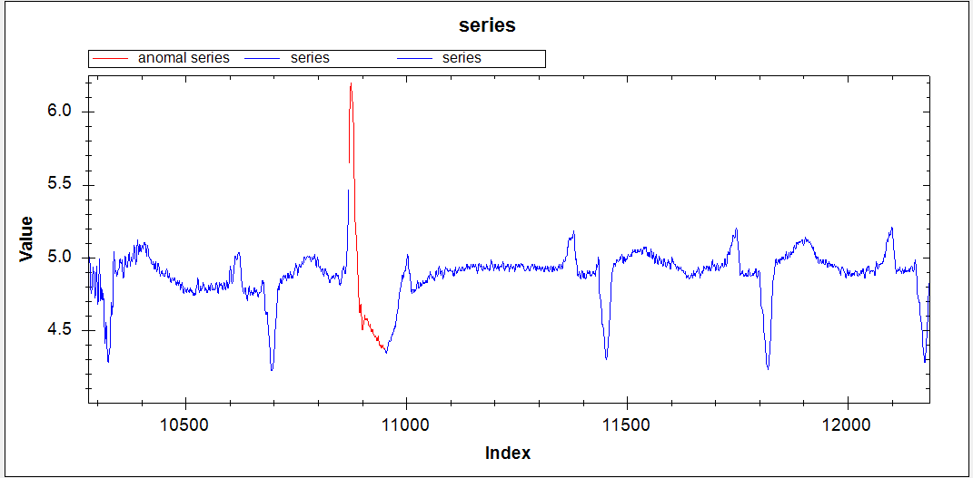

(0-21599), 3, 0.3, 2, 3, (10870 - 10951)(19796-20215), 00:01:27

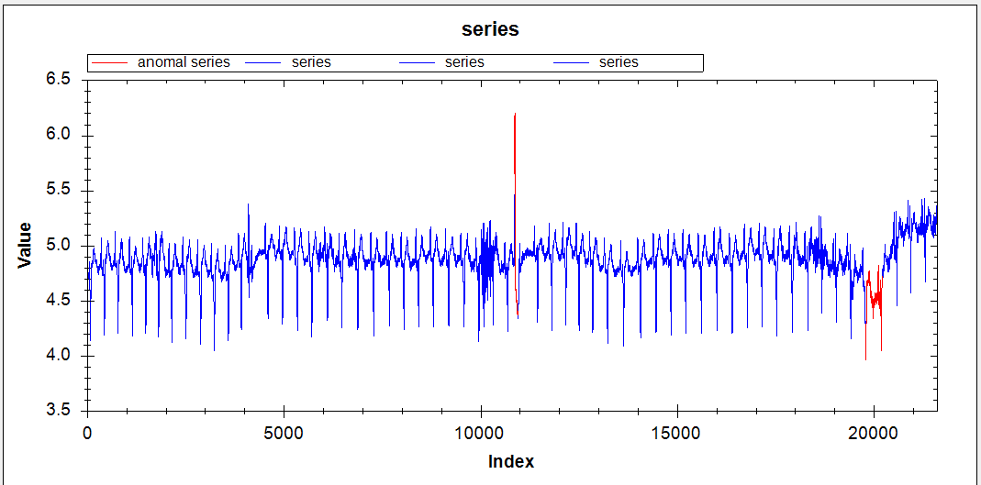

(0-21599), 3, 0.3, 3, 3, (19796-20215) (10870 - 10951), 00:01:09

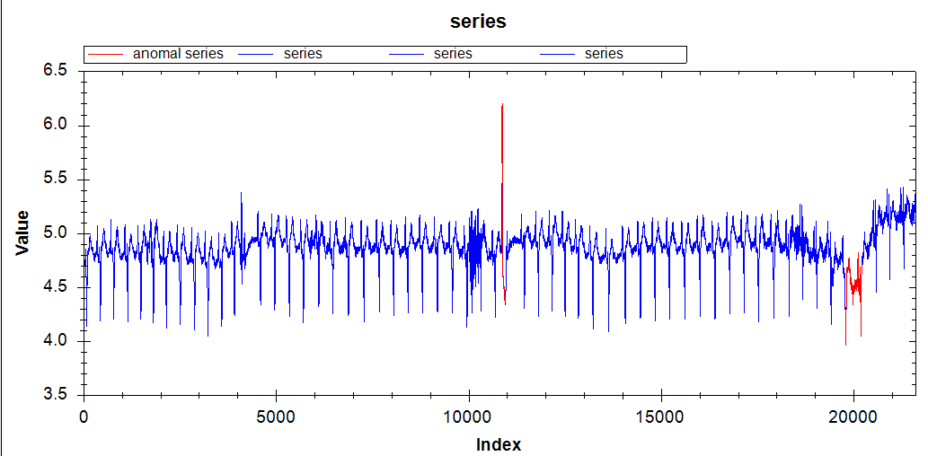

(0-21599), 3, 0.1, 1, 3, (10870 - 10951) (19796-20215), 00:01:33

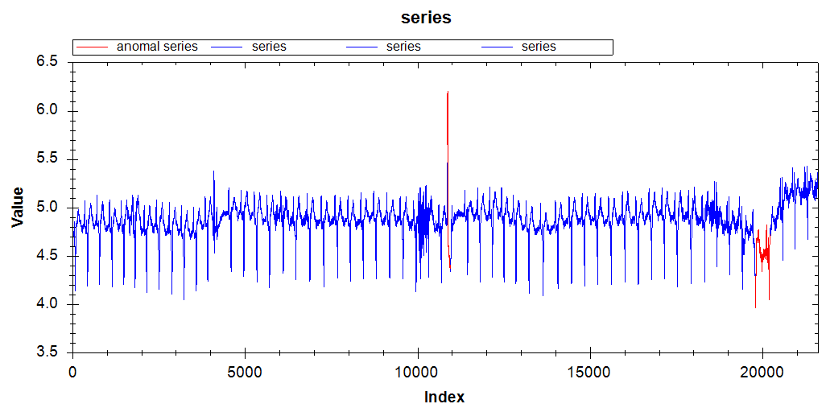

(0-21599), 3, 0.5, 1, 3, (20003 - 20215) (19773-19888), 00:00:34

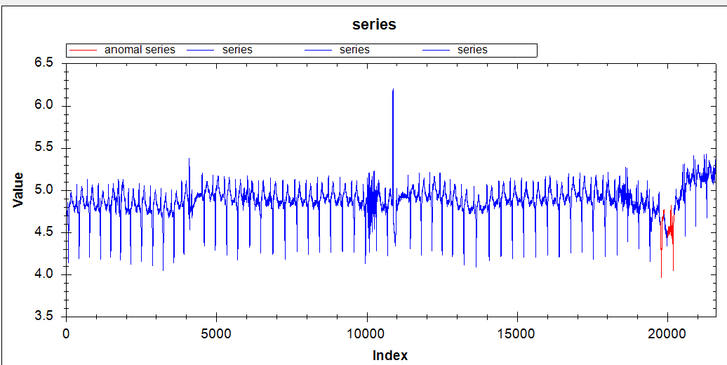

(0-21599), 3, 0.7, 1, 3, (19981 - 20214) (0-158), 00:00:33

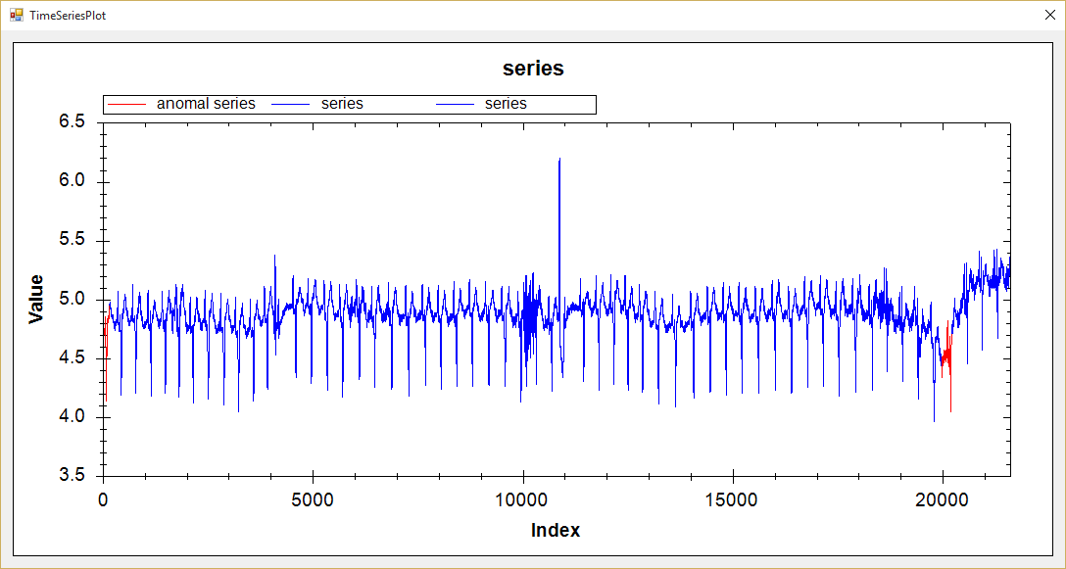

(0-21599), 2, 0.3, 1, 3, (10867 - 10897) (19933-20190), 00:01:03

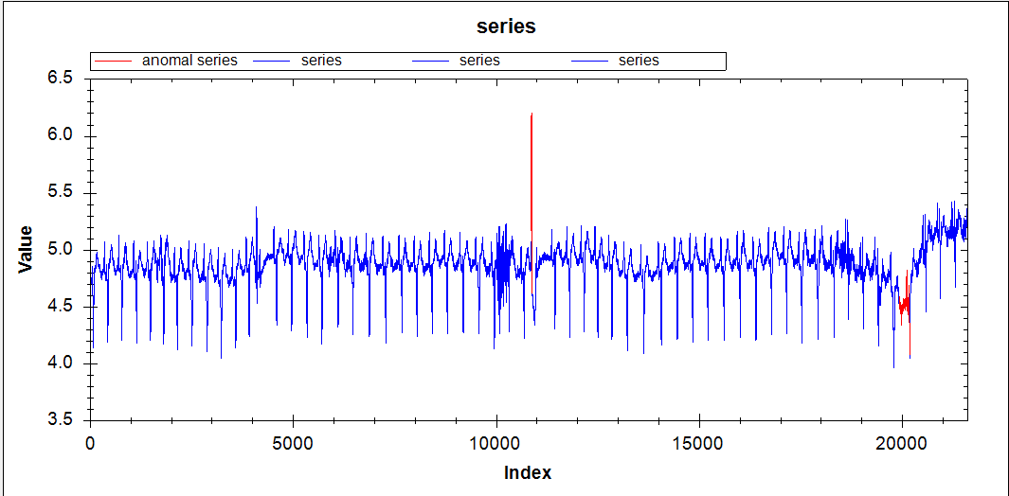

(0-21599), 4, 0.3, 1, 3, (10874 - 10995) (19416-19797), 00:01:12

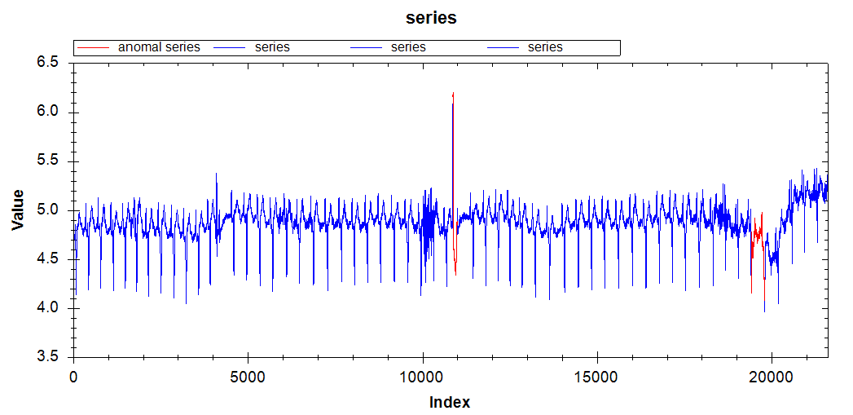

(0-21599), 5, 0.3, 1, 3, (19780 - 20327) (10875-11010), 00:01:29

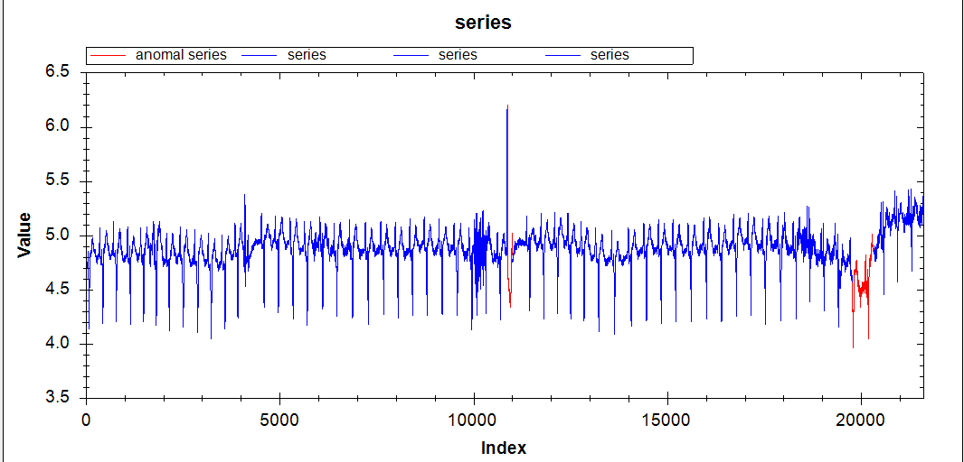

(0-21599), 3, 0,3,1,2, (10870 - 11377)( 19453 - 20215)( 20871 - 21051),00:01:25

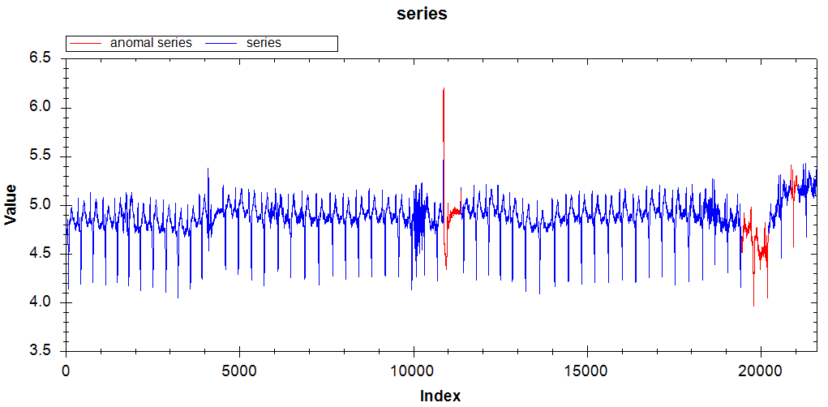

2/ **VL With Extrem points: length, R, minLength, k, alpha, anomalies, time**

(0-21599), 1.04, 50, 1, 3, (10850 - 11454) (19579 - 20357)( 9962 - 10518) (4088 – 4534), 00:15:00

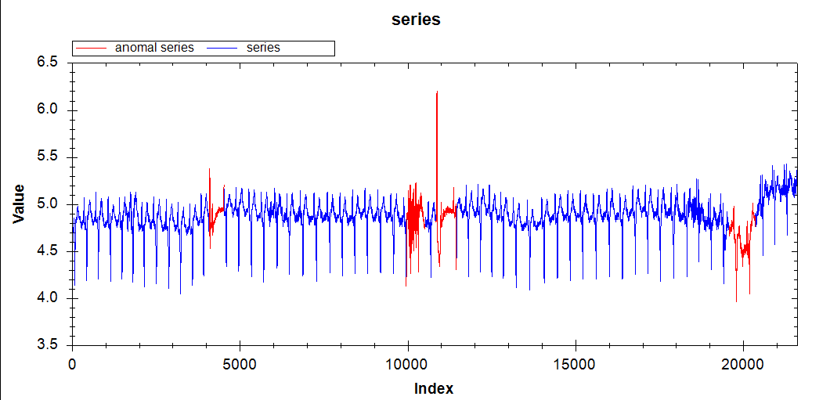

**3/ Hot Sax: length, discord length, PAA length, begin of discord, time**

(0-21599), 128, 8, 10857, 00:12:54

